83 Render - Render Output
Render Panel 1
Display 1
Output Options 2
Dimensions panel 2
Output Panel 3
Video Output 4
Preparing your work for video 4
Safe Areas and Overscan 4
Enabling Safe Areas 5
Color Reproduction 5
Encoding Panel 5
Rate 7
Mux 7
Audio 7
Tips 8
Metadata 8
Animation Player 10
Shortcuts 10

Render Panel

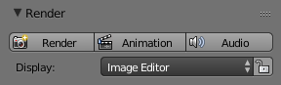
Render panel.
Render F12
Starts rendering a still image of the current frame.
Animation Ctrl-F12
Starts rendering an animation. See Rendering Animations for more detail.
Audio
Mixes all the audio found in a scene and saves into one file. See Introduction.
By default the biggest area is replaced with the UV/Image Editor and the render appears.
To cancel the rendering process click the cancel button X besides the progressbar in the Info Editor, or press Esc.

Display
Renders are displayed in the UV/Image Editor. You can set the way this is displayed to several different options in the Display menu:
Display
Keep UI
The image is rendered to the UV/Image Editor, but the UI remains the same. You will need to open the UV/Image Editor manually to see the render result.
New Window
A new floating window opens up, displaying the render.
Image Editor
One of the existing editors is replaced with the UV/Image Editor, showing the render.
Full Screen
The UV/Image Editor replaces the UI, showing the render.
Lock Interface
Lock interface during rendering in favor of giving more memory to the renderer.

Output Options

The first step in the rendering process is to determine and set the output options. This includes render size, frame rate, pixel aspect ratio, output location, and file type.

Dimensions panel
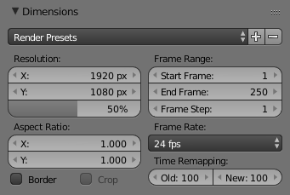
Dimensions Panel.
Render Presets
Common format presets for TVs and screens.
Resolution
X/Y
The number of pixels horizontally and vertically in the image.
Percentage
Slider to reduce or increase the size of the rendered image relative to the X/Y values above. This is useful for small test renders that are the same proportions as the final image.
Aspect Ratio
Older televisions may have non-square pixels, so this can be used to control the shape of the pixels along the respective axis. This will pre-distorted the images which will look stretched on a computer screen, but which will display correctly on a TV set. It is important that you use the correct pixel aspect ratio when rendering to prevent re-scaling, resulting in lowered image quality.
See Video Output for details on pixel aspect ratio.
Border
You can render just a portion of the view instead of the entire frame. While in Camera View, press Ctrl-B and drag a rectangle to define the area you want to render. Ctrl-Alt-B is the shortcut to disable the border.
Note
This disables the Save Buffers option in Performance and Full Sample option in Anti-Aliasing.
Enabling Crop will crop the rendered image to the Border size, instead of rendering a black region around it.
Frame Range
Set the Start and End frames for Rendering Animations. Step controls the number of frames to advance by for each frame in the timeline.
Frame Rate
For an Animation the frame rate is how many frames will be displayed per second.
Time Remapping
Use to remap the length of an animation.

Output Panel
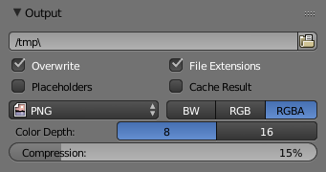
Output panel.
This panel provides options for setting the location of rendered frames for animations, and the quality of the saved images.
File Path
Choose the location to save rendered frames.
When rendering an animation, the frame number is appended at the end of the file name with four padded zeros (e.g. image0001.png). You can set a custom padding size by adding the appropriate number of # anywhere in the file name (e.g. image_##_test.png translates to image_01_test.png).
This setting expands relative paths where a // prefix represents the directory of the current blend-file.
Overwrite
Overwrite existing files when rendering.
Placeholders
Create empty placeholder frames while rendering.
File Extensions
Adds the correct file extensions per file type to the output files.
Cache Result
Saves the rendered image and passes to a Multilayer EXR-file in temporary location on your hard drive. This allows the compositor to read these to improve performance, especially for heavy compositing.
Output Format
Choose the file format to save to. Based on which format is used, other options such as channels, bit-depth and compression level are available.
For rendering out to images see: saving images for rendering to videos see rendering to videos
Color Mode
Choose the color format to save the image to. Note that RGBA will not be avaible for all image formats.
BW, RGB, RGBA
Hint
Primitive Render-Farm
An easy way to get multiple machines to share the rendering workload is to:
- Set up a shared directory over a network file-system.
- Disable Overwrite, enable Placeholders in the Render Output panel.
- Start as many machines as you wish rendering to that directory

Video Output

Preparing your work for video
Once you master the art of 3D animation, you will probably want to share your work with others; either on the internet (YouTube, Vimeo, etc) or with family and friends (DVD/Bluray) or even possibly for television broadcast.
To spare you some disappointment, here are some tips specifically targeted at video preparation.

Safe Areas and Overscan
For anyone creating motion graphics or simple text overlays, overscan is an important consideration. Although its origins are rooted in historic analog TV systems, unfortunately even in 2017, for various reasons it can still be an issue with modern digital flatscreen TVs.
Note
Due to various limitations in analog TV equipment, the displayed image could sometimes end up shifted horizontally or vary in size, which could lead to the area beyond the intended visible picture being shown. This hidden area sometimes contained junk noise, timing signals or closed-caption/subtitle data. To avoid this being visible to the viewer, the standard approach for TV manufacturers was to ‘overscan’ (zoom in) the displayed picture by a small amount (between 5-10% edge crop) to ensure that at no time would the hidden areas be visible.
Although modern digital electronics have eliminated the issue of shifting image position, unfortunately, some TV manufacturers have included overscan on their flatscreen TVs. Why? Because for many years it was given that the edge of the visible image would rarely be seen, so broadcasters would sometimes overlay ‘hidden’ data to the very edge of the image (e.g. some types of closed captions). Also, legacy analog recordings might still contain unwanted noise around the edge. To avoid consumer complaints, overscan is quite often enabled by default. For some flatscreen TVs, it is not possible to disable it.

Enabling Safe Areas
Blender has configurable safe-area markings which can be made visible by selecting the scene camera, then in the camera settings by enabling Safe Areas. Several presets are available. If you are producing work for a television network or indeed any client, they may have their own rules and requirements on safe area dimensions – so consult with them.

Color Reproduction
When exporting to many of the common video formats, the rendered RGB(A) images go through a conversion process whereby they are translated to the YCbCr color model. Y corresponds to a grayscale representation of the image, Cb and Cr contain data for the blue and red channels respectively. Green is encoded into the Y and Cb, Cr channels with some clever math.
Importantly, the color components are often stored at a lower resolution to the Y (grayscale) channel. This can cause blurring/smearing which can be a problem with small text and some saturated color combinations – so it is well worth doing test encodes to make sure that text remains legible. As with safe areas, a TV network or client might have their own rules on minimum text size and positioning, so always seek clarification when unsure.

Encoding Panel
Reference
Panel: Properties editor ‣ Render ‣ Encoding

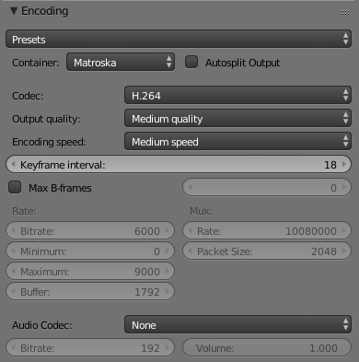
Encoding panel.
Here you choose which video container, codec, and compression settings you want to use. With all of these compression choices, there is a tradeoff between file size, compatibility across platforms, and playback quality.
Tip
When you view the System Console, you can see some of the output of the encoding process. You will see even more output if you execute Blender as blender -d.

Presets
You can use the presets, which choose optimum settings for you for that type of output.
Container
Video container or file type. For a list of all available options, see video formats.
Autosplit Output
If your video is huge and exceeds 2GiB, enable Autosplit Output. This will automatically split the output into multiple files after the first file is 2Gig.
Codec
Chooses the method of compression and encoding. For a list of all available options see video formats.
Note
Standards
Some containers and codecs are not compatible with each other, so if you are getting errors check that your container and codec are compatible. Like containers and codecs are sometimes not compatible with each other, some codecs do not work with arbitrary dimensions. So, try to stick with common dimensions or research the limitations of the codec you are trying to use.

Output Quality
These are preset Rates
Encoding Speed
Presets to change between a fast encode (bigger file size) and more compression (smaller file size)
Key Frame Interval
The number of pictures per Group of Pictures. Set to 0 for “intra_only”, which disables inter-frame video. A higher number generally leads to a smaller file but needs a higher-powered device to replay it.
Max B-frames
Enables the use of B-frames.
Interval
The maximum number of B-frames between non-B-frames.

Rate
Bitrate
Sets the average bitrate (quality), which is the count of binary digits per frame. See also: FFmpeg -b:v.
Rate
Video files can use what is called variable bitrate (VBR). This is used to give some segments of the video less compressing to frames that need more data and less to frames with less data. This can be controlled by the Minimum and a Maximum values.
Buffer
The decoder bitstream buffer size.

Mux
Multiplexing <http://www.afterdawn.com/glossary/term.cfm/multiplexing>`__ is the process of combining separate video and audio streams into a single file, similar to packing a video file and .mp3 audio file in a zip-file.
Rate
Maximum bit rate of the multiplexed stream.
Packet Size
Reduces data fragmentation or muxer overhead depending on the source.

Audio
Audio Codec
Audio format to use. For a list of all available options, see video formats.
Bitrate
For each codec, you can control the bitrate (quality) of the sound in the movie. Higher bitrates are bigger files that stream worse but sound better. Use powers of 2 for compatibility.
Volume
Sets the output volume of the audio.

Tips
The choice of video format depends on what you are planning to do.
It’s not recommended to render directly to a video format in the first instance. If a problem occurs while rendering, the file might become unplayable and you will have to re-render all frames from the beginning. If you first render out a set of static images such as the default PNG format or the higher-quality OpenEXR (which can retain HDR pixel data), you can combine them as an Image Strip in the Video Sequence Editor (VSE). This way, you can easily:
- Restart the rendering from the place (the frame) where any problem occurred.
- Try out different video encoding options in seconds, rather than minutes or hours as encoding is usually much faster than rendering the 3d scene.
- Enjoy the rest of the features of the VSE, such as adding Image Strips from previous renders, audio, video clips, etc.
You shouldn’t post-process a lossy-compressed file as the compression artifacts may become visible. Lossy compression should be reserved as a final ‘delivery format’.
If you are planning on doing significant post-processing and color correction, it is best to output a frameset rendered in OpenEXR format. If you plan to do only minimal changes after rendering and would prefer a single file, choose lossless H.264 for high quality, or regular H.264 for lower quality.

Metadata

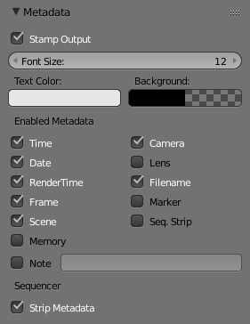
Metadata panel.
The Metadata panel includes options for writing meta-data into render output.
Note
Only some image formats support metadata: See image formats.

Stamp Output
Add metadata as text to the render.
Stamp Text Color
Set the color and alpha of the stamp text.
Stamp Background
Set the color and alpha of the color behind the text.
Font Size
Set the size of the text.
Draw Labels
Draws the labels before the metadata text. For example, “Camera” infront of camera name etc.
Enabled Metadata
Stamping can include the following data.
Time
Includes the current scene time and render frame at HH:MM:SS.FF
Date
Includes the current date and time.
Render Time
Includes the render time.
Frame
Includes the frame number.
Scene
Includes the name of the active scene.
Memory
Includes the peak memory usage.
Note
Includes a custom note.
Hint
It can be useful to use the Note field if you are setting up a render-farm.
Since you can script any information you like into it, such as an identifier for the render-node or the job-number.
For details on stamping arbitrary values, see: this page.
Camera
Includes the name of the active camera.
Lens
Includes the name of the active camera’s lens value.
Filename
Includes the filename of the blend-file.
Marker
Includes the name of the last marker.
Seq. Strip
Includes the name of the foreground sequence strip.
Sequencer
Strip Metadata
Use metadata from the strips in the sequencer.

Animation Player

The Info Editor ‣ Render ‣ Play Rendered Animation menu will play back the rendered animation in a new window.
You can also drop images or movie files in a running animation player. It will then restart the player with the new data.
An external player can also be used instead of the one included in Blender. To do this, select it in the User Preferences.

Shortcuts
The following table shows the available hotkeys for the animation player.
Playback
Action | Hotkey
Start/Pause: | Spacebar
Start playback (when paused): | Enter
Quit: | Esc
Timeline
Action | Hotkey
Scrub in time: | LMB
Step back one frame: | Left
Step forward one frame: | Right
Step back 10 frames: | Down
Step forward 10 frames: | Up
Manual frame stepping: | NumpadPeriod
Playback Options
Action | Hotkey
Backward playback: | Shift-Down
Forward playback | Shift-Up
Slow down playback: | Minus
Speed up playback: | Plus
Toggle looping: | Numpad0
Toggle frame skipping: | A
Toggle ping-pong: | P
Display
Action | Hotkey
Toggle Time Cursor (Indicator): | I
Flip drawing on the X axis: | F
Flip drawing on the Y axis: | Shift-F
Hold to show frame numbers: | Shift
Zoom in: | Ctrl-Plus
Zoom out: | Ctrl-Minus
Frame rate
- 60 fps Numpad1
- 50 fps Numpad2
- 30 fps Numpad3
- 25 fps Numpad4
- 24 fps Shift-Numpad4
- 20 fps Numpad5
- 15 fps Numpad6
- 12 fps Numpad7
- 10 fps Numpad8
- 6 fps Numpad9
- 5 fps NumpadSlash

